MILESAGO – Media – Print

DAILY PLANET
Rock magazine, Melbourne, 1971-7?

Editor: Lee Dillow
Art director: Ian McCausland
Advertising manager: Terry Cleary
Photography: David Porter (aka Jacques L’Afrique, Jack Africa)

Contributing journalists:
David N. Pepperell (“Dr Pepper”)
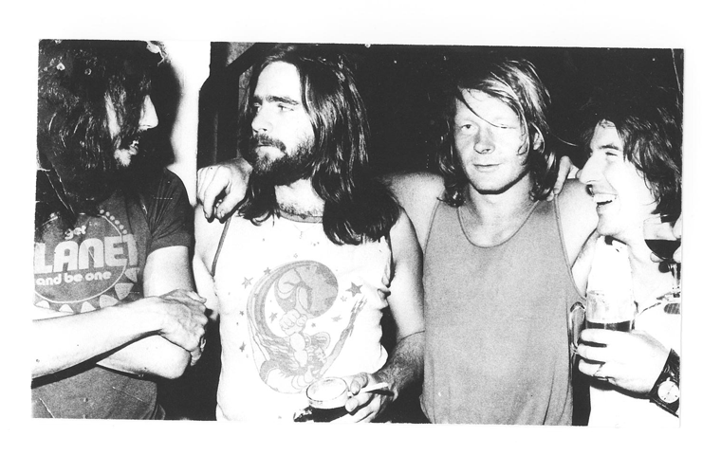
A rare photo of the Planet team: L-R Ian McCausland - layout, art; Lee Dillow – editor; the late Terry Cleary - advertising (ex GoSet); Dave Porter (alias Jacques L'Afrique alias Jack Africa) - photography. (Photo courtesy of David Pepperell)

Daily Planet was established in 1971 by Michael Gusinski and Michael Browning, as an attempt to create a Rolling Stone style alternative to Australia’s pop bible. Go-Set.

